Step 1. Create TIN Matching file for upload to IRS E Services web site.

Click TINLetters icon to launch the program. The following window will appear:

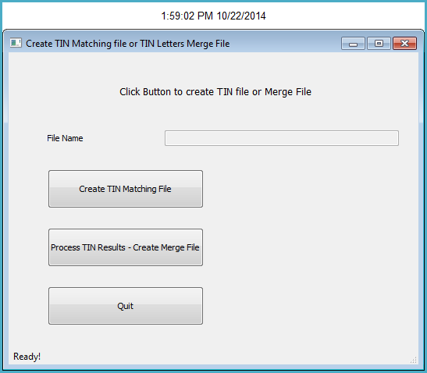

The program will run very quickly and produce the following message. Click the Ok button to clear the message. Click the Show Details… button to see a record count.

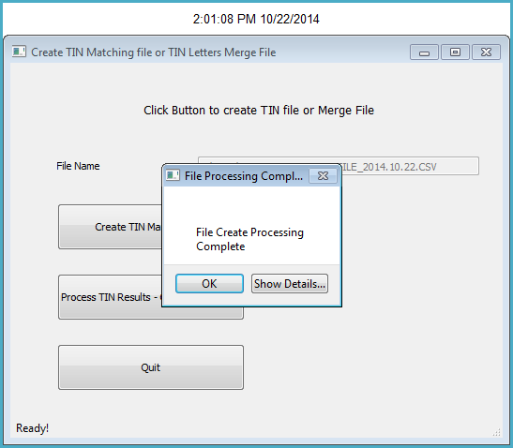

After clearing the message box, you will see the file name text box has been populated with the name and location of the file.

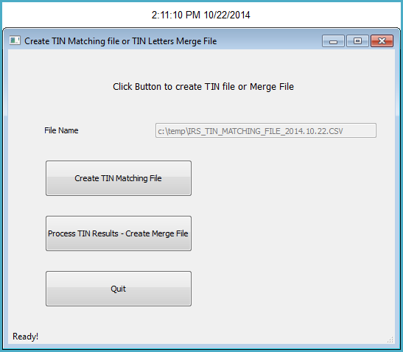

File Name

The file name will be located in the C:\temp folder.

It will be named IRS_TIN_MATCHING_FILE_ with the date the file was created concatenated to the end.

Next step is to upload the file to the IRS E Services web site.

The web site address is:

<http://www.irs.gov/Tax-Professionals/e-services---Online-Tools-for-Tax-Professionals>

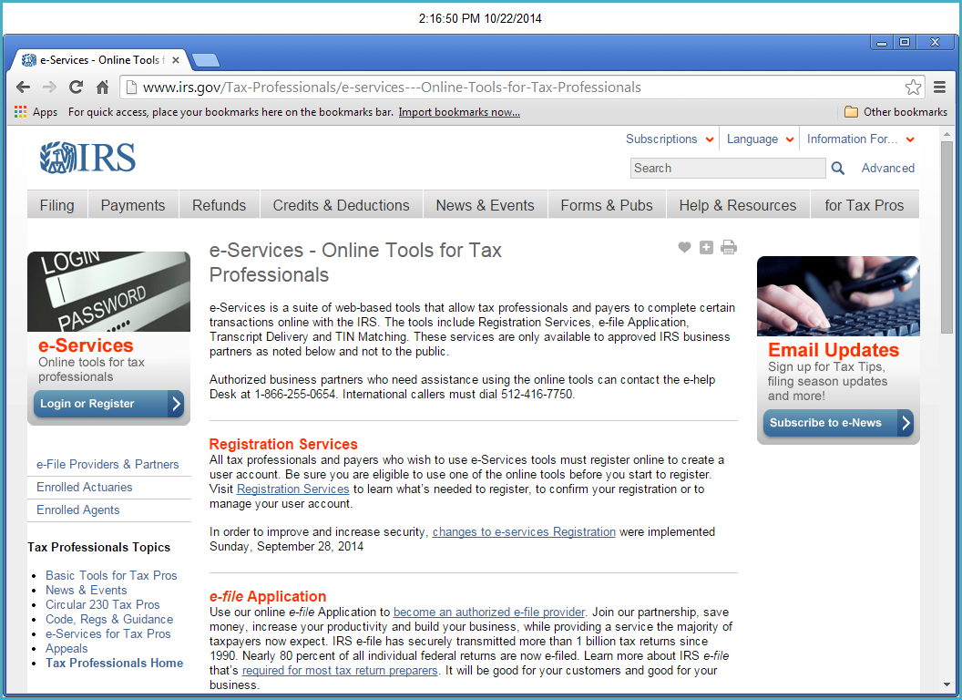

Click here to login

Click the Login button and the following page will appear:

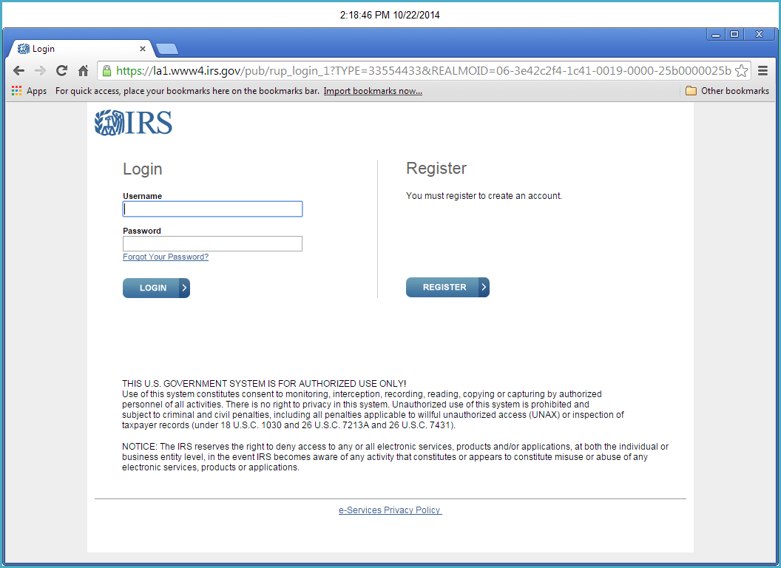

The user id is: Flagler14; password is Password14; both are case sensitive. Enter the login credentials and click the login in button. The following page will appear:

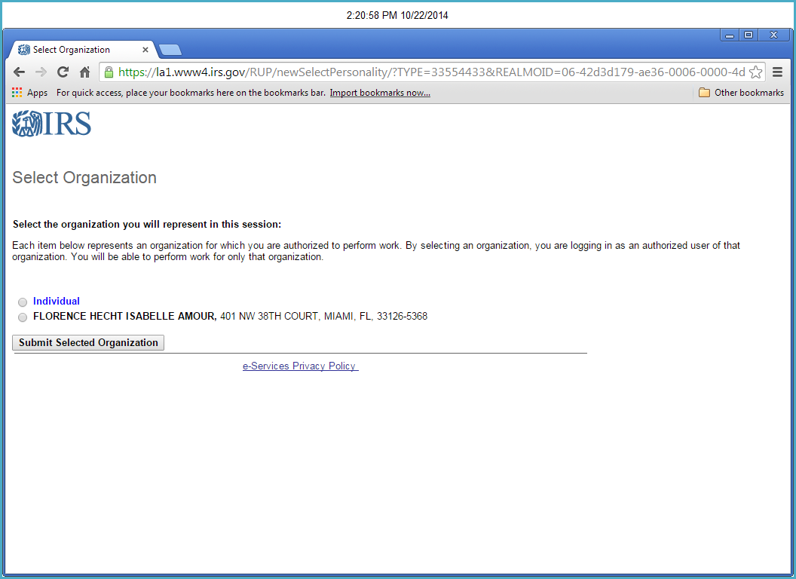

Then click here.

Click the radio button next to Florence first.

The following page will appear:

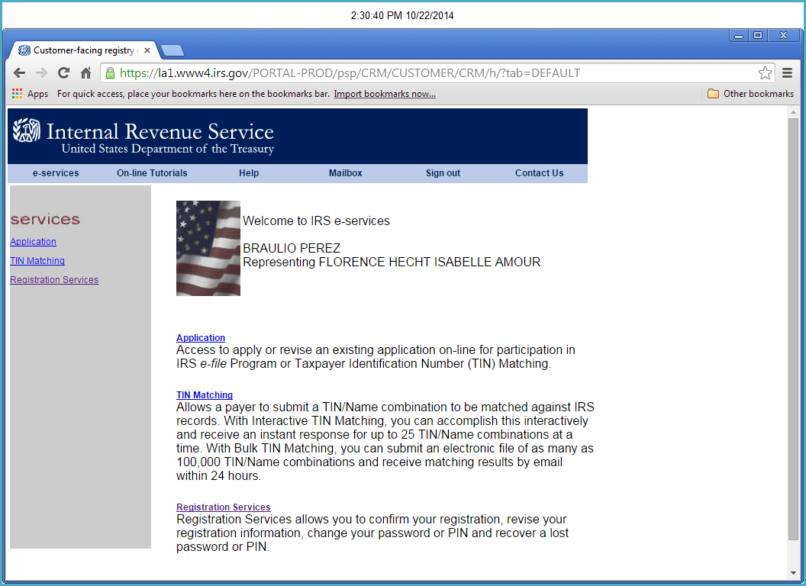

Click here

Click on the TIN Matching link on the left side of the page.

The following page will appear, click the TIN Matching link again.

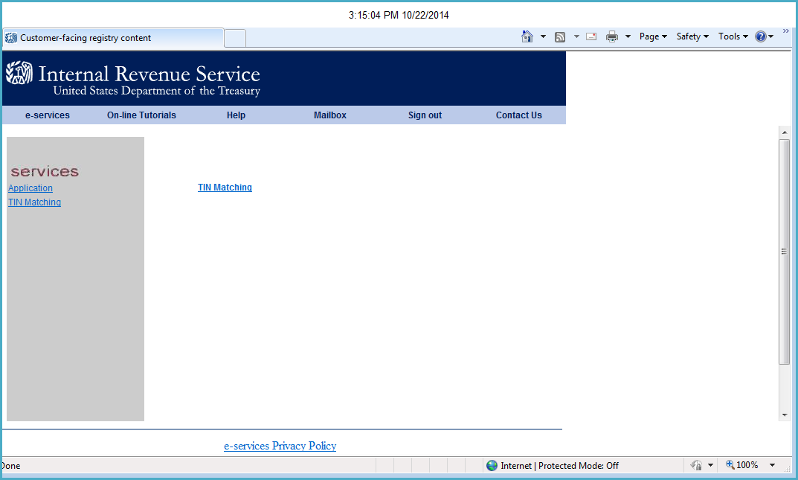

Click Here

The following page will appear. Click Accept button.

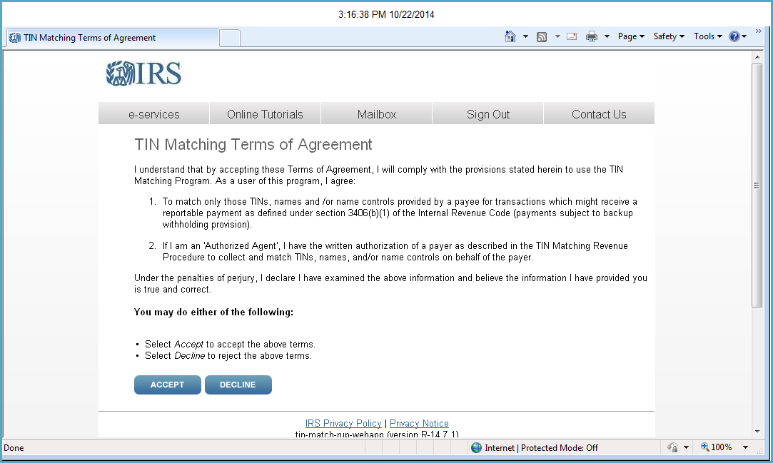

The following page will appear. Click on Begin Bulk TIN Session.

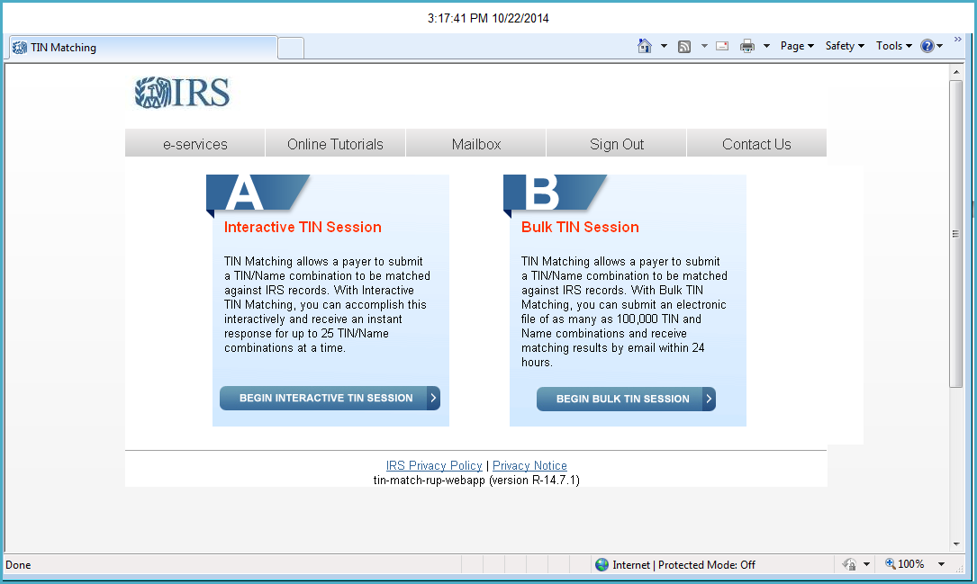

Click Here

The following screen will appear. Click the Browse button to select the file to be uploaded.

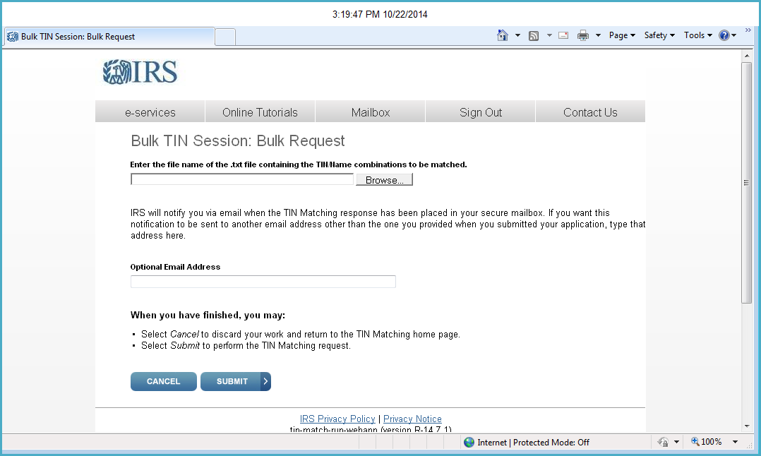

Click Here

The select file dialog box will appear. Navigate to the C:\temp folder and select the file to upload.

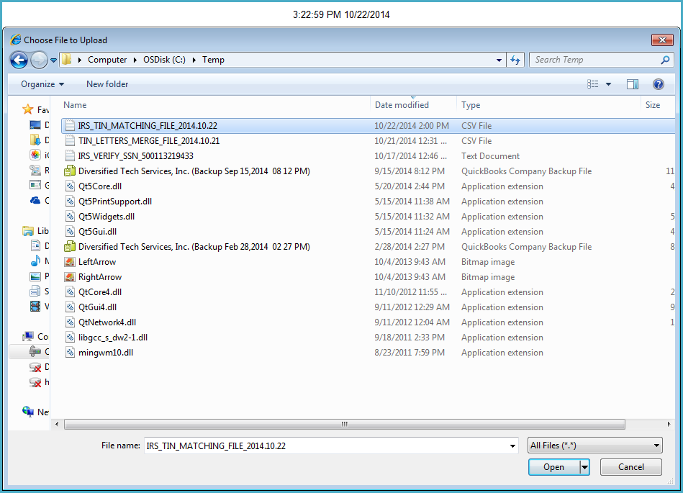

Select the file and click the open button. The file dialog box will close.

The page will appear as shown below. Click on the submit button to submit the file for processing.

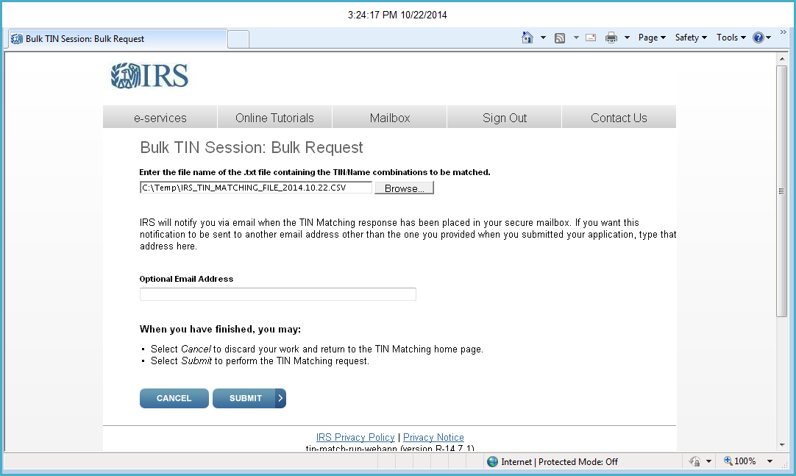

The page will appear as shown below. Click the Done button.

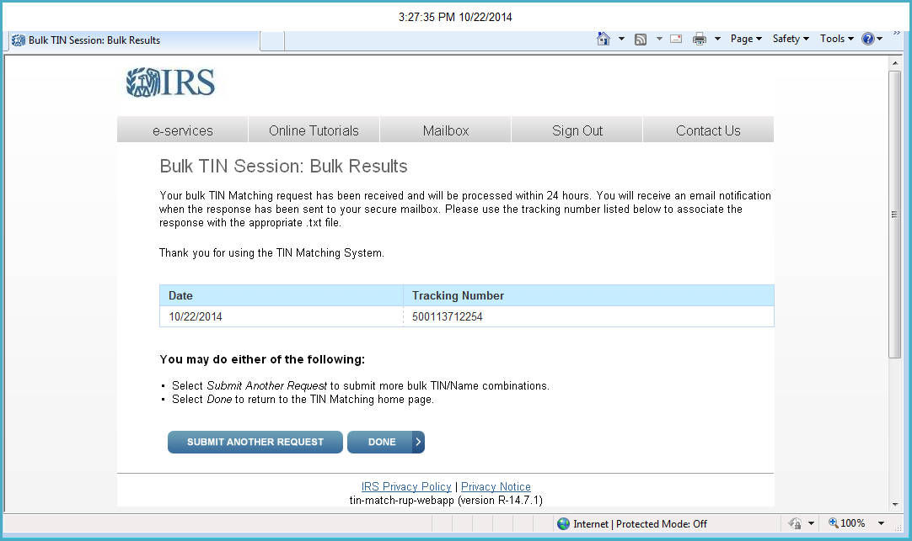

Click on the Sign Out link to exit.

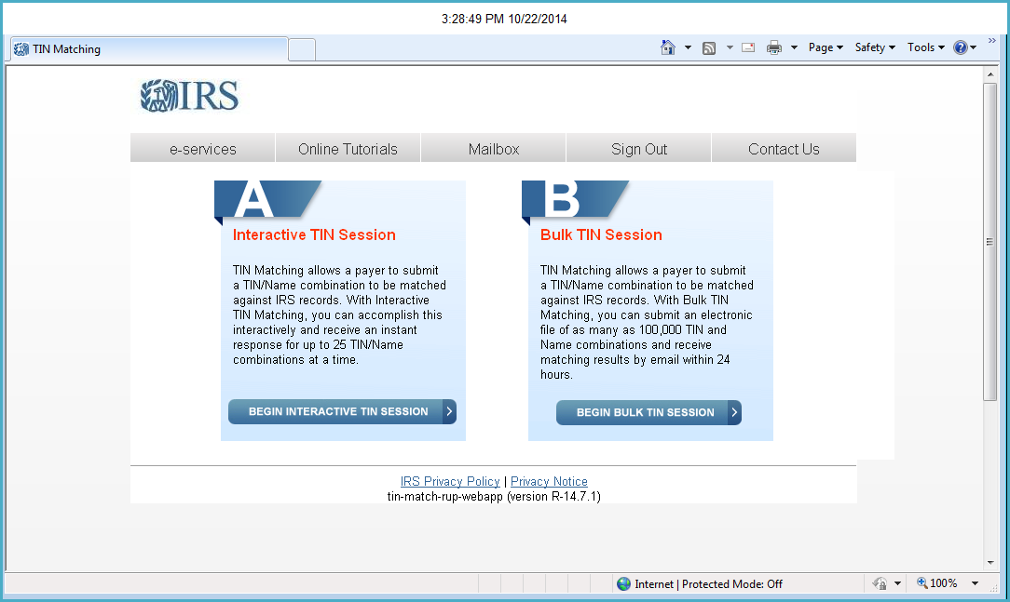

Click Here

After 24 hours, log back in using the same procedure. Then, click on the Mailbox link.

Click Here



Click on the filename highlighted

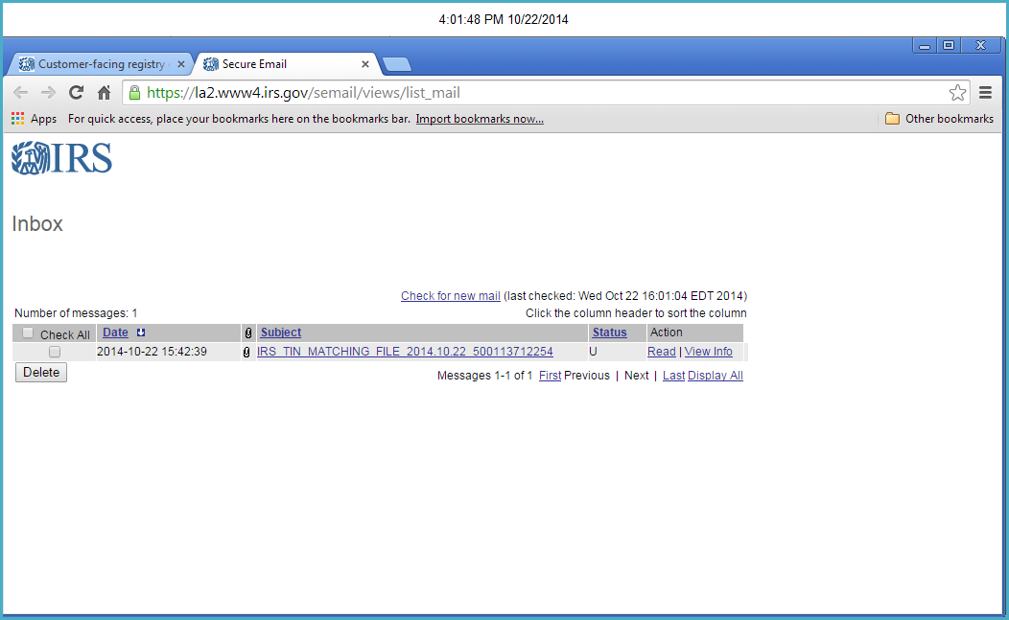

Click Here

Click on the download link as shown below

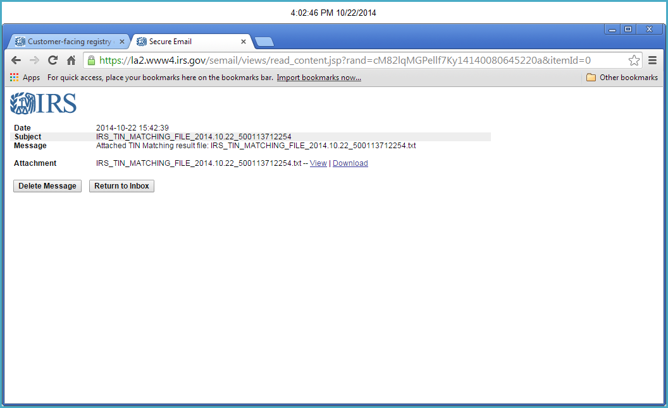

Click Here

Down load the file. Copy the file from the Downloads file to the c:\temp\folder

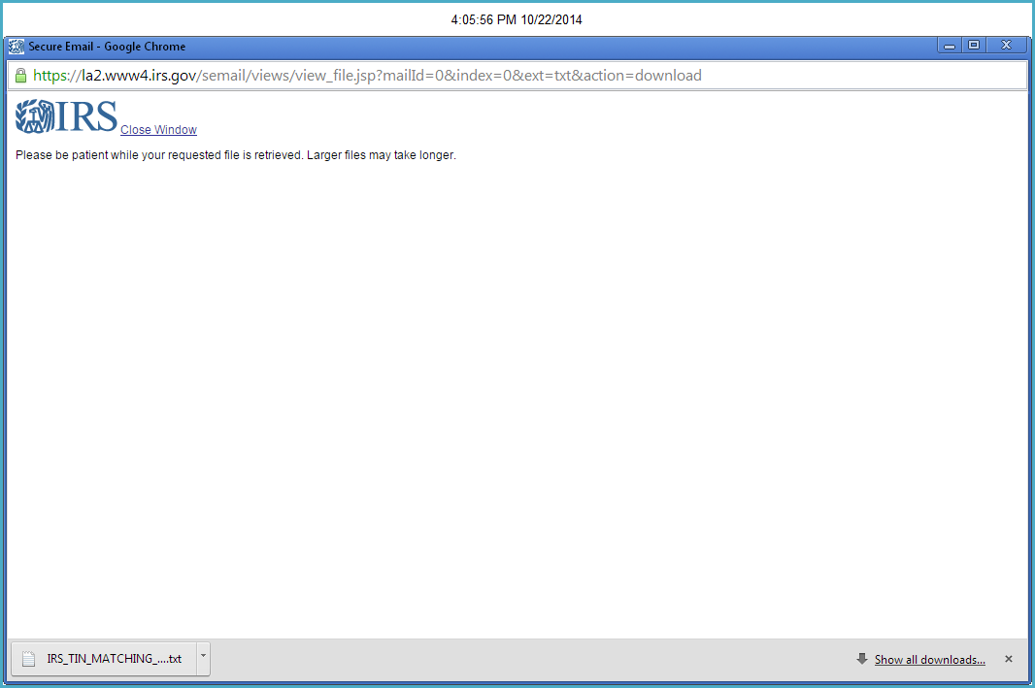

Start the TINLetters program again. This time, click the Process TIN results – Create Merge File button.



Click Here

The file dialog window will open. Select the file just downloaded from the IRS site and then click the open button.

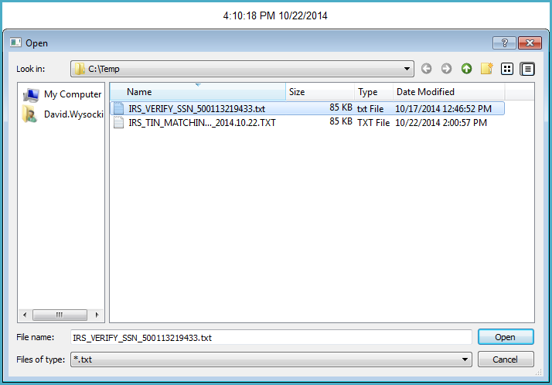

Click Here

The file dialog window will disappear and the program will process the file and generate the Microsoft Word merge file. Click the Ok button to clear the message, then click the Quit button.

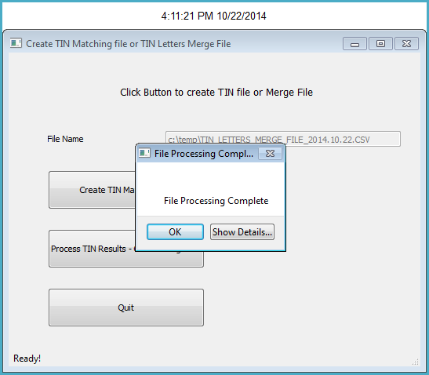

Final step to create and print the merge letters. Start Microsoft Word and open the Letter template. You will see the following dialog box appear, click the No button.

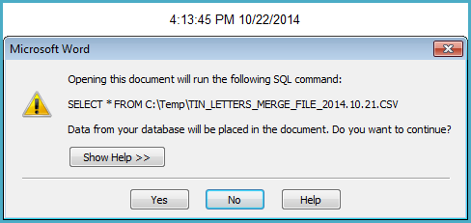

Click Here

The letter template as shown here. Click on the Mailings menu item.

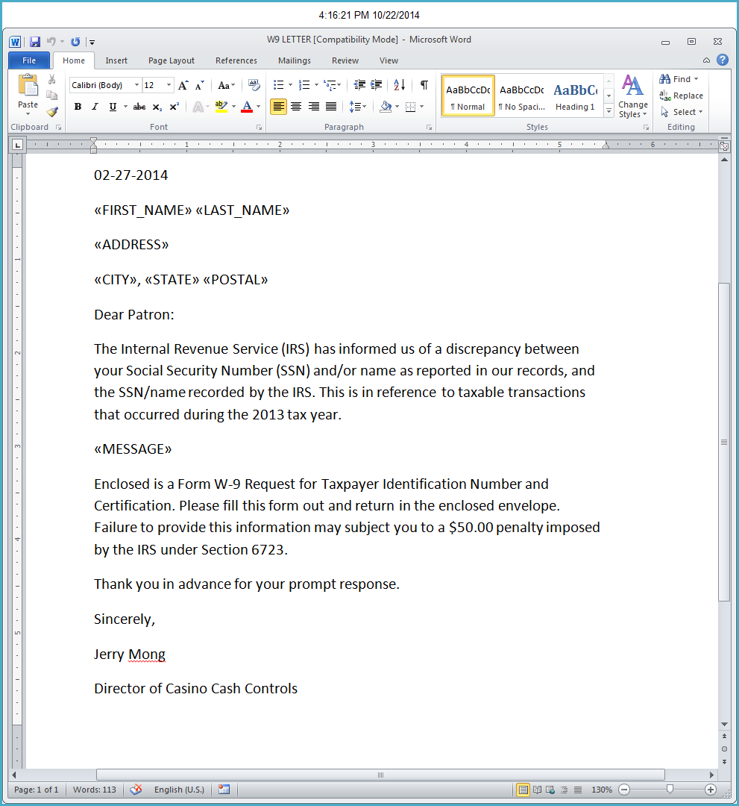

Click Here

Click on the Select Recipients button.

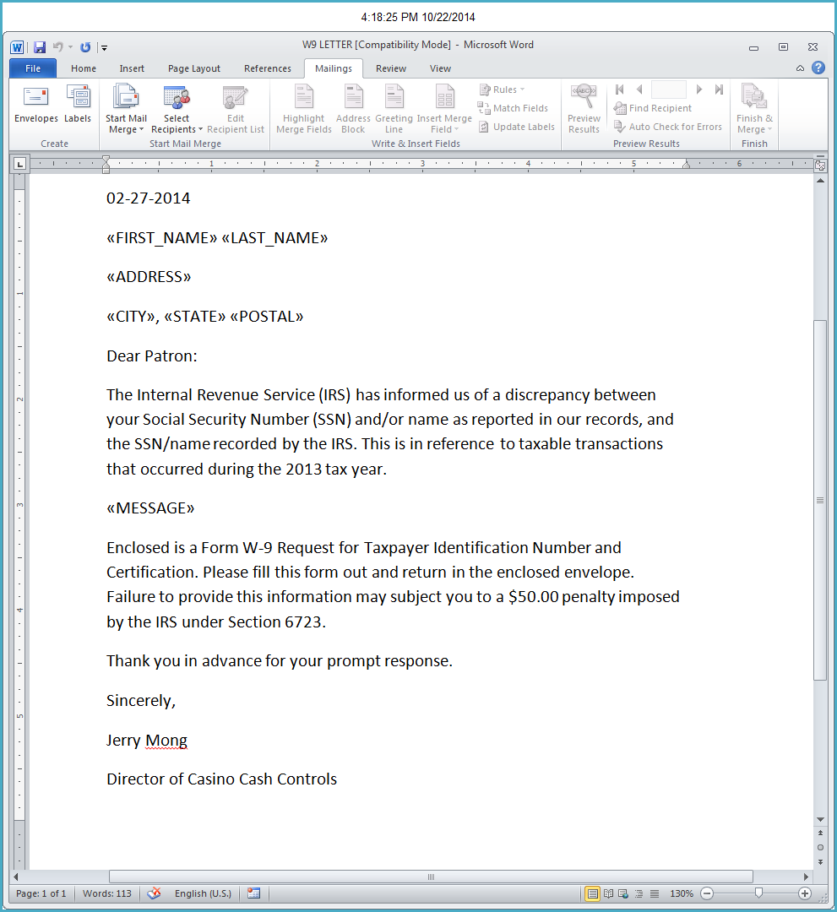

Click Here

Choose use existing list as shown here.

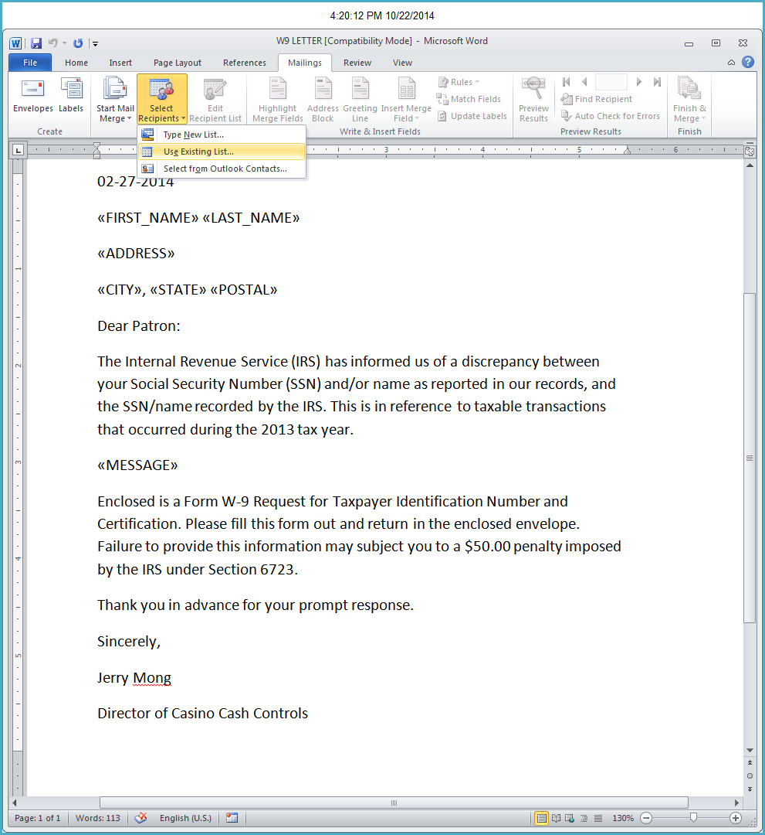

Click Here

Navigate to the c:\temp\folder and select the merge file named TIN_LETTERS_MERGE_FILE_….

The date the file was created will be concatenated to the file name as shown here. Select the file and click the open button.

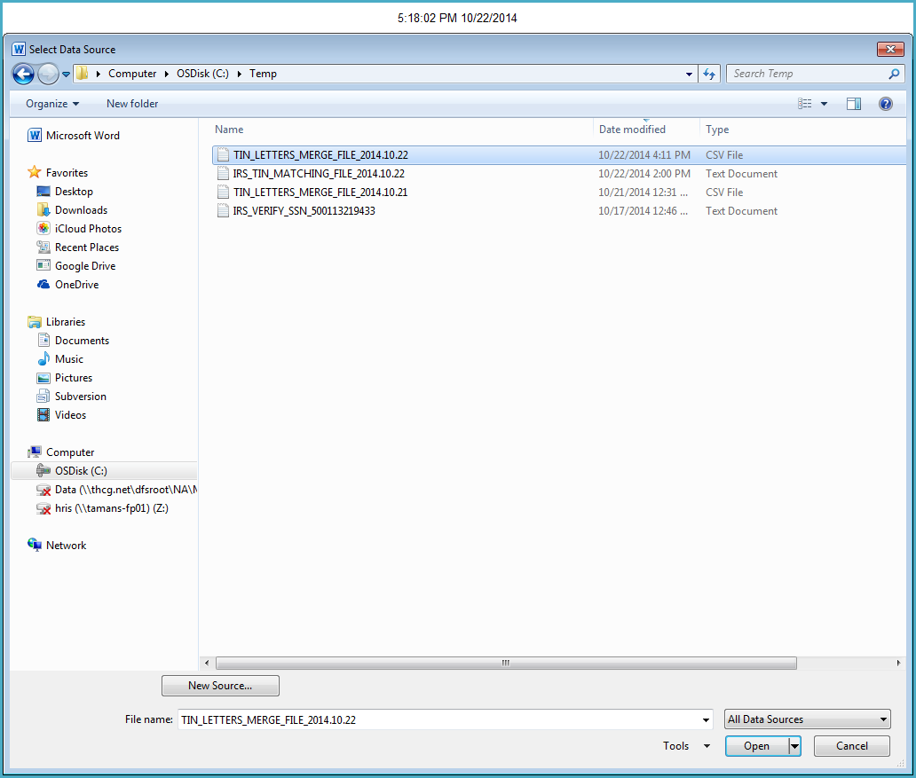

Click on the Finish & Merge button. Choose Edit Individual Documents from the drop down list.

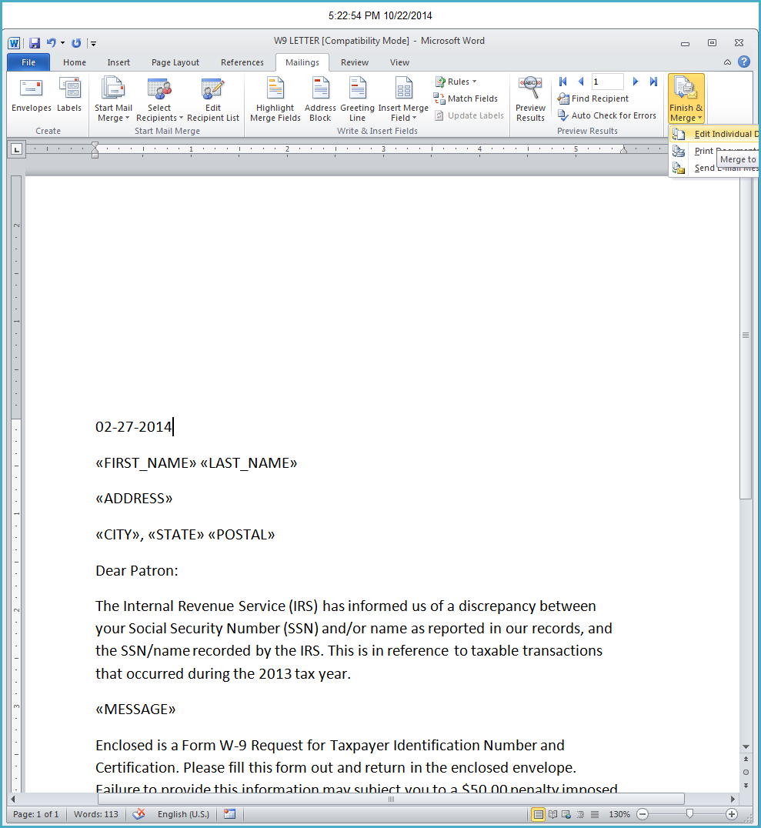

Click Here

Be sure All is selected as shown here. And Click Ok button. A new word document will be created with one page for each individual who’s TIN was reported as invalid.

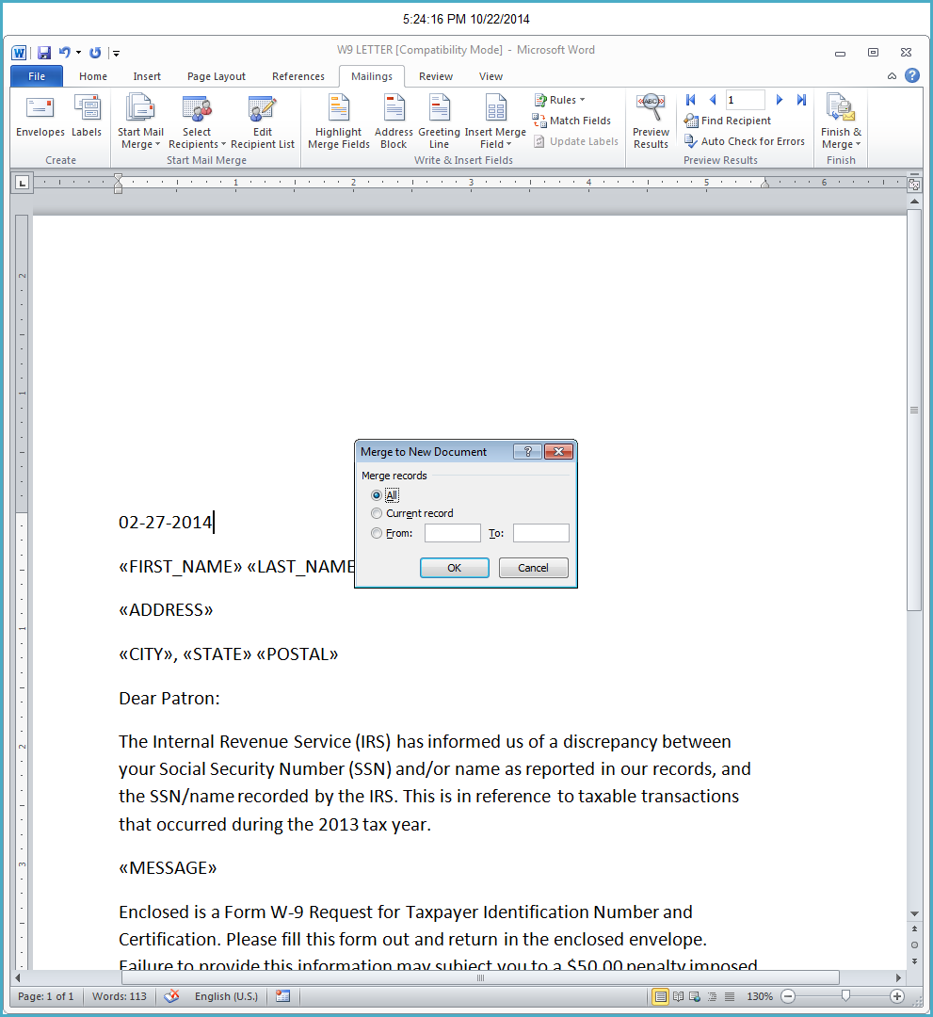

Click Here

A new word document will be created with one page for each individual who’s TIN was reported as invalid.

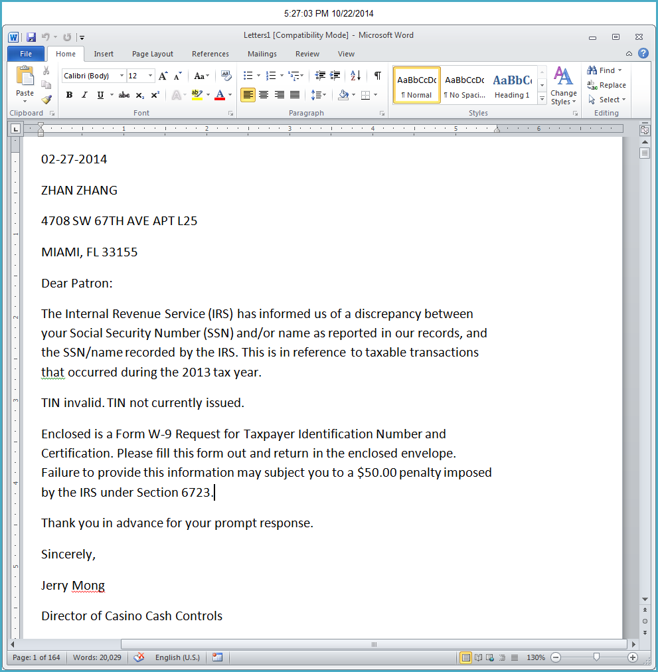

Notice there are 164 pages. Or 164 letters to print and mail.